AUTO BREAKING SYSTEM FOR FOUR WHEELER

SYNOPSIS

The aim is to design and develop a control system based an intelligent electronically controlled automotive breaking system is called “INTELLIGENT BREAKING SYSTEM”. This Breaking system is consists of IR transmitter and Receiver circuit and the vehicle. The IR sensor is used to detect the obstacle. There is any obstacle in the path, the IR sensor senses the obstacle and giving the control signal to the breaking system. The relay is used to disconnect the motor supply voltage.

INTRODUCTION

We have pleasure in introducing our new project “INTELLIGENT BREAKING SYSTEM”, which is fully equipped by IR sensors circuit and electronic breaking circuit. It is a genuine project which is fully equipped and designed for Automobile vehicles. This forms an integral part of best quality. This product underwent strenuous test in our Automobile vehicles and it is good.

BLOCK DIAGRAM

CONTROL UNIT

IR TRANSMITTER

IR RECEIVER

BATTERY

RELAY

PERMANENT MAGNET D.C. MOTOR

WORKING OPERATION

The IR TRANSMITTER circuit is to transmite the Infra-Red rays. If any obstacle is there in a path, the Infra-Red rays reflected. This reflected Infra-Red rays are received by the receiver circuit is called “IR RECEIVER”.

The IR receiver circuir receives the reflected IR rays and giving the control signal to the control circuit. The control circuit is used to activate the relay, so that motor will stop.

APPLICATIONS

- For automobile application
- Industrial application

ADVANTAGES

- Brake cost will be less.
- Free from wear adjustment.
- Less power consumption
- Less skill technicians is sufficient to operate.
- It gives simplified very operation.
- Installation is simplified very much.
- To avoid other burnable interactions viz.… (Diaphragm) is not used.

DISADVANTAGES
- Additional cost is required for automation

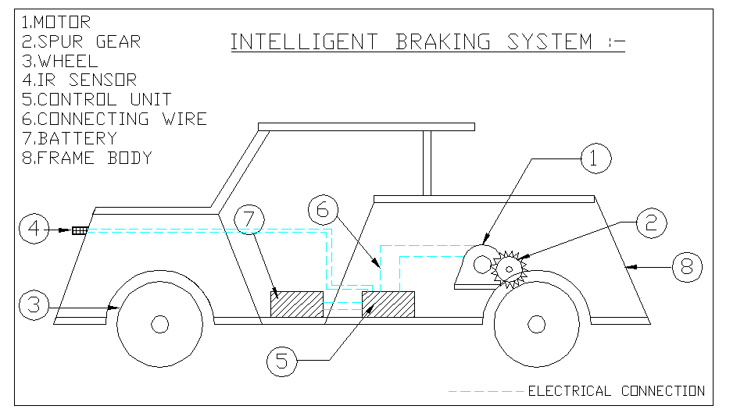
AUTO BREAKING SYSTEM FOR
FOUR WHEELER:-

